ASTA 607
COMPUTIONAL STATISTICS 1
22425128
QUESTION 1
- The crabs data frame has 200 rows and 8 columns, describing 5 morphological measurements on 50 crabs each of two colour forms and both sexes, of the species Leptograpsus variegatus collected at Fremantle, W. Australia.
- The crabs data is saved as a data frame made of 200 observations of 8 variables. The species (sp) variable is a factor with two levels, sex is also a factor with 2 levels. Index is an integer and the remaining are numeric.
Codes:
library(MASS)
library(psych)
data("crabs")
str(crabs)

Code:
table(crabs$sp, crabs$sex)

output
> table(crabs$sp, crabs$sex)

F M
B 50 50
O 50 50

Code:
library(ggplot2)
ggplot(crabs, aes(x = sp, fill = sex)) +
geom_bar(position = "stack") +
labs(title = "Crab Group Composition by Species and Sex",
x = "Species",
y = "Count",
fill = "Sex") +
theme_minimal()

output

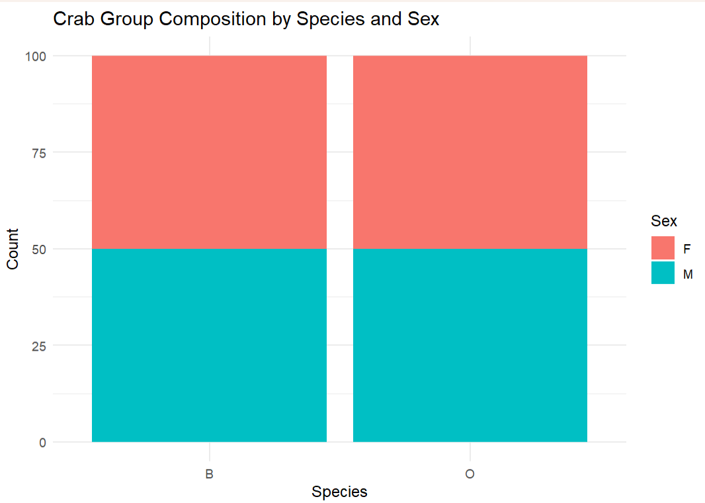

- The data is perfectly balanced across species and sex. Both sexes have 50 observation each and both species also have 50 observations each.
QUESTION 2

Code
ggplot(crabs, aes(x = interaction(sp, sex), y = BD, fill = sex)) +
geom_boxplot() +
labs(title = "Body Depth by Species and Sex",
x = "Group (Species-Sex)",
y = "Body Depth (BD)") +
theme_minimal()

output
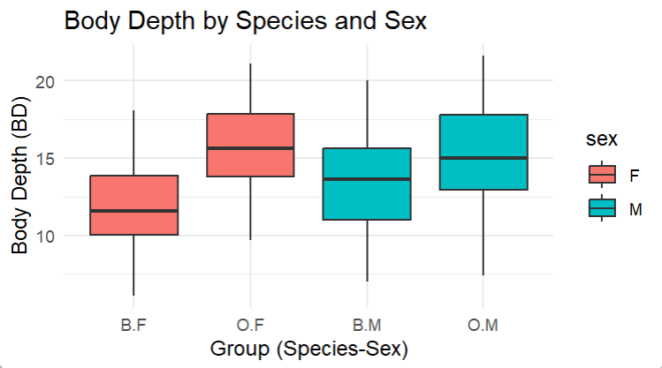

- Kkkk

QUESTION 3
- Codes
hist(crabs$CL[crabs$sp == "B"],
main = "Histogram of Carapace Length (Blue Crabs)",
xlab = "Carapace Length (CL)",
col = "lightblue",
border = "black")
hist(crabs$CL[crabs$sp == "O"],
main = "Histogram of Carapace Length (Orange Crabs)",
xlab = "Carapace Length (CL)",
col = "lightcoral",
border = "black")

output
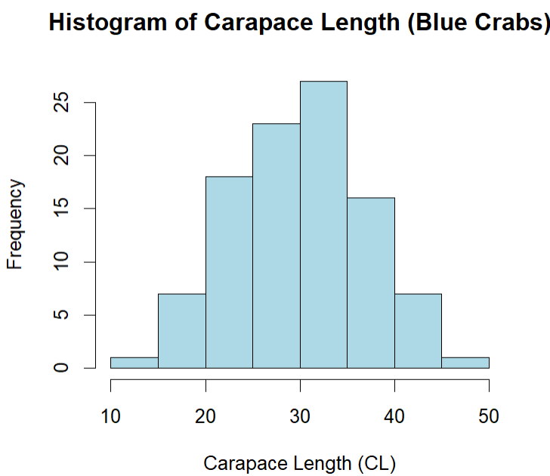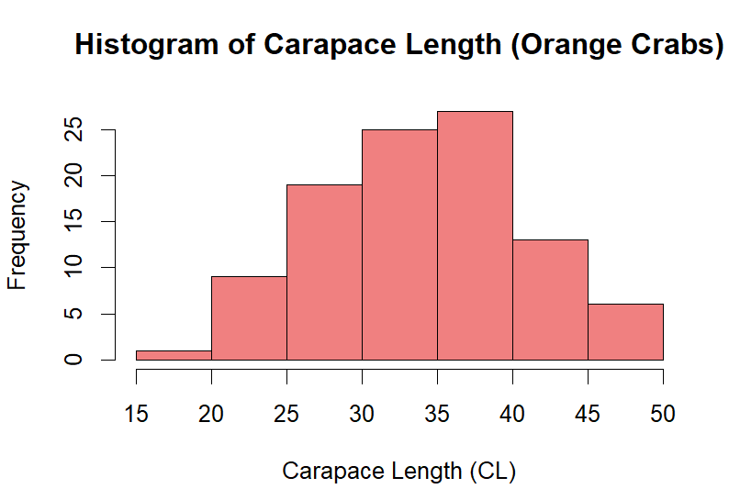

- The histogram for both species show very similar shapes. Both shows single clear mode signifying that both are unimodal. Orange crabs are almost numeric while blue crab show a slight skewing to the right.
QUESTION 4
- Codes
(means <- aggregate(cbind(FL, RW, CL, CW, BD) ~ sp + sex, data = crabs, mean))

Output
> ##q4
> ## a) means of each morphological measurement by species and sex
> (means <- aggregate(cbind(FL, RW, CL, CW, BD) ~ sp + sex, data = crabs, mean))
sp sex FL RW CL CW BD
1 B F 13.270 12.138 28.102 32.624 11.816
2 O F 17.594 14.836 34.618 39.036 15.632
3 B M 14.842 11.718 32.014 36.810 13.350
4 O M 16.626 12.262 33.688 37.188 15.324

- Codes
means_matrix<- as.matrix(means[, -c(1,2)])
rownames(means_matrix) <- paste(means$sp, means$sex, sep = "-")
means_matrix
barplot(t(means_matrix),
beside = TRUE,
col = 2:6,
legend.text = rownames(means_matrix),
args.legend = list(x = "topright", bty = "n"),
main = "Mean Morphological Measurements by Species and Sex",
ylab = "Mean Value",
xlab = "Morphological Measurements")

output
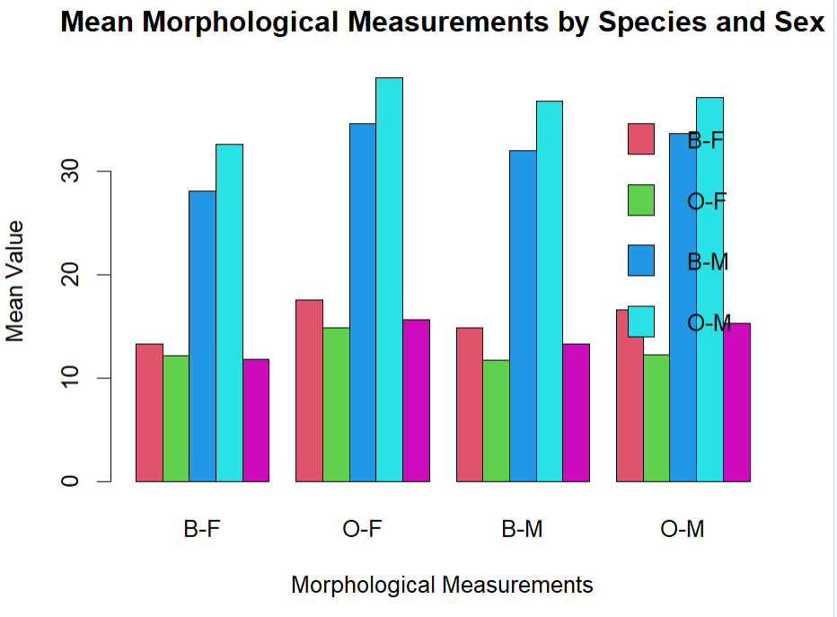

- Hhhhh
QUESTION 5
- Codes
crabs_measurements<-crabs[, c("FL", "RW", "CL", "CW", "BD")]
pairs(crabs_measurements,
main = "Scatter Plot Matrix of Crab Measurements",
pch = 20, col = "black")

output
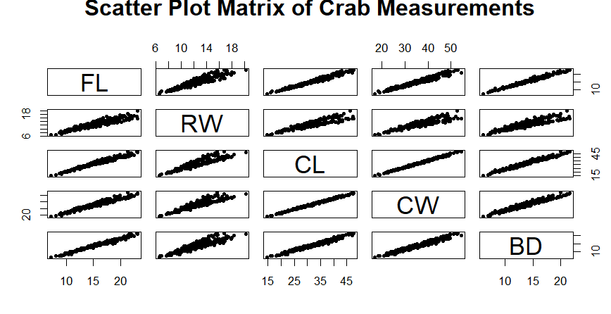

- The variables show strong linear relationships.

QUESTION 5
The data has 200 observations categorized by sex and species. Each specie has exactly 50 observations showing perfectly balanced data. Body depth as examined across the four species-sex groups using side-by-side boxplots shows distributions are unimodal and approximately symmetric.

